Kafka Consumer Drawing

Generic

Kafka config

Step 2

Step 3

Step 7

Step 6

Step 5

Step 4

Step 1

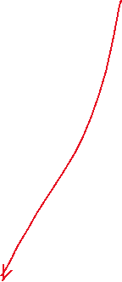

Schema file to define the structure

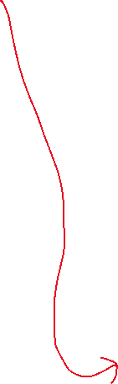

Topic name

Insert many

Mongodb operation

Sensor record

Consumer data from kafka

Consumer and Specify a group name

Json deserializer

Topic name

Get Schema Structure

Json Consumer

Dict to object

Provide schema using file

Kafka Cluster config

Schema config

Kafka Producer drawing

Step 5

Step 2

Step 3

3

Step4

Step 1

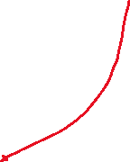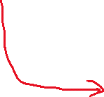

Kafka

Json Producer

Provide data

Schema file to define the structure of data

Send data to Kafka

Producer

Json Serializer

Get Schema Structure

Topic name and file location

Topic name and sample data file

Json record generator

Provide schema using file.

Generic

Kafka Cluster Config

Schema Config

Kafka config